Burke Lake Park Explorer:
A Mobile-Friendly GIS Application Using User-Centered Design

Henry Stepanus
GEOG 777
University of Wisconsin–Madison
March 27, 2026

1. Introduction
This project presents a mobile-friendly web mapping application designed for Burke Lake Park in Fairfax County, Virginia. The goal of the application is to improve visitor navigation, safety awareness, and park experience through an interactive GIS-based interface.
Burke Lake Park is a large recreational area that includes trails, fishing areas, parking lots, facilities, and environmentally sensitive zones. Due to the park’s size and diversity of features, visitors often need accessible and intuitive spatial information to navigate effectively. This application addresses that need by providing a user-centered mapping interface.

2. User-Centered Design
User Persona
Name: Sarah Kim
Profile: Casual weekend visitor with family
Needs:
- Find restrooms and parking quickly
- Identify easy trails for children
- Report hazards (e.g., fallen trees)
- Navigate efficiently using mobile device
User Stories:
- As a visitor, I want to search for facilities, so I can quickly find restrooms and services.
- As a hiker, I want to filter trails by difficulty, so I can choose appropriate routes.
- As a user, I want to report issues, so park management can respond.
- As a visitor, I want to use my current location, so I can orient myself within the park.

3. Application Features (Functions)
The application includes more than four required functions:
1. Search Function
Users can search for trails, facilities, and parking areas using keyword input.
2. Filtering Function
Users can filter trails based on:
- Difficulty (easy, moderate, hard)
- Maximum trail length
3. User Submission (Report System)
Users can:
- Drop a pin on the map
- Submit a report with category, description, and optional photo URL
- Reports are validated (minimum 20-character description)
4. Device Location (Near Me)
Users can locate themselves using geolocation and center the map accordingly.
5. Layer Toggle
- Users can enable/disable:
- Trails
- Facilities
- Parking
- Sensitive areas
- User reports

4. Data Layers
The application includes at least 5 layers:
- Trails (Line)
- Digitized manually for accuracy
- Includes attributes: difficulty, surface, length
- Facilities (Point/Polygon)
- Includes restrooms, visitor centers, playgrounds
- Uses custom symbology (icons)
- Parking (Polygon)
- Represents parking areas with capacity attributes
- Sensitive Areas (Polygon)
- Includes ecological or restricted zones
- User Reports (Point)
- User-generated data layer
- Basemap (OpenStreetMap)
- Provides geographic context

5. Data Collection and Processing
Initial data was created using approximate GeoJSON layers.
To improve spatial accuracy, features such as trails, facilities, and parking were:
- Digitized manually using umap software on openstreetmap
- Cleaned and structured into GeoJSON format
- Standardized with consistent attributes
This significantly improved the realism and usability of the application.

6. Backend Design (ER Diagram & Logical Schema)
Although the deployed version runs on GitHub Pages (frontend only), the application is designed to integrate with a backend system using PostgreSQL/PostGIS.
- Entities
- Park
- Trail
- Facility
- Parking
- Sensitive Area
- User Report
- Logical Schema

park (
park_id PK,
name,
location
)

trail (
trail_id PK,
park_id FK,
name,
difficulty,
length_mi,
geom
)

facility (
facility_id PK,
park_id FK,
name,
type,
geom
)

parking (
parking_id PK,
park_id FK,
capacity,
geom
)

user_report (
report_id PK,
park_id FK,
category,
description,
photo_url,
status,
created_at,
geom
)

ER Diagram (Description)
- One park → many trails
- One park → many facilities
- One park → many reports
- Reports linked to spatial locations
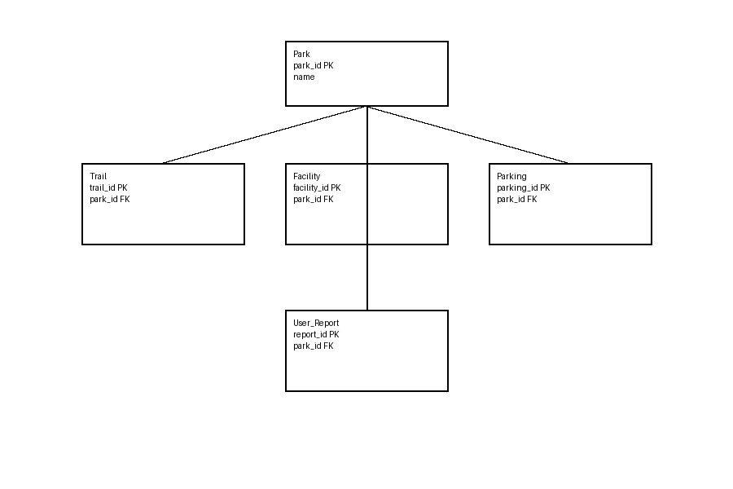
7. System Architecture
Frontend
- Leaflet.js (mapping)
- HTML/CSS/JavaScript
- GitHub Pages deployment
Backend (Planned)
- Node.js + Express
- PostgreSQL/PostGIS
Data Storage
- GeoJSON (current demo)
- PostGIS (future implementation)

8. User Interface Design
The application is designed to be mobile-friendly:
- Compact top search panel
- Bottom sliding panel for tools
- Minimal visual clutter
- Icon-based symbology (restrooms, parking, etc.)
This design improves usability and reduces cognitive load.

9. Limitations and Future Improvements
Limitations
- No persistent database (demo version)
- Reports are stored client-side only
- Some attributes are simplified
Future Improvements
- Deploy backend API
- Store reports in PostGIS
- Add real-time updates
- Improve symbology with custom icons
- Add routing/navigation

10. Conclusion
This project demonstrates how GIS and user-centered design can be combined to create an effective, mobile-friendly park navigation tool. The application supports real-world use cases such as navigation, facility discovery, and issue reporting, while maintaining a clean and intuitive interface. The system is scalable and can be extended into a full production-level GIS application.
Map link: https://hstepanus.github.io/Geog777_Project_2/

